| **For Registration Module** |
| --- |

| **Url** | **Controller** | **Services** | **Methods** |  |
| --- | --- | --- | --- | --- |
| <http://localhost:4200> | Student | Student | GET | *App is running or not* |
| <http://localhost:4200>/stu/addStudent | Student | Student | POST | *Adding a single Student* |
| <http://localhost:4200>/stu/addStudents | Student | Student | POST | *Adding more than one Student* |
| <http://localhost:4200>/stu/getStudentByID/{id} | Student | Student | GET | *Getting a particular student by id* |
| <http://localhost:4200>/stu /getStudentByName/{name} | Student | Student | GET | *Getting a student by name* |
| <http://localhost:4200>/stu/updateStudent | Student | Student | PUT | *Updating a particular student data* |
| <http://localhost:4200>/stu/deleteStudentById/{id} | Student | Student | DELETE | *Deleting a particular student data* |
| <http://localhost:4200>/stu/getAll | Student | Student | GET | *Getting all the students data* |

| **For Login Module** |
| --- |

| <http://localhost:4200> | User | User | GET | *App is running or not* |
| --- | --- | --- | --- | --- |
| <http://localhost:4200>**/**users/token | User | User | POST | *To Login* |
| <http://localhost:4200>**/**users**/**update | User | User | PUT | *To change Password* |
| <http://localhost:4200>**/**admin**/**token | Admin | Admin | POST | *To Login as admin* |
| <http://localhost:4200>**/**admin**/**update | Admin | Admin | PUT | *To change Admin’s Password* |

| **For Question Module** |
| --- |

| <http://localhost:4200> | User | User | GET | *App is running or not* |
| --- | --- | --- | --- | --- |
| <http://localhost:4200>**/**users/token | User | User | POST | *To Login* |
| <http://localhost:4200>**/**users**/**update | User | User | PUT | *To change Password* |
| <http://localhost:4200>**/**admin**/**token | Admin | Admin | POST | *To Login as admin* |
| <http://localhost:4200>**/**admin**/**update | Admin | Admin | PUT | *To change Admin’s Password* |

| **For Rules Module** |
| --- |

| <http://localhost:4200> | Rule | Rule | GET | *App is running or not* |
| --- | --- | --- | --- | --- |
| <http://localhost:4200>**/**emp/getAll | Rule | Rule | GET | *To get all the Rules* |
| <http://localhost:4200>**/**emp/addRule | Rule | Rule | POST | *To add a Rule* |
| <http://localhost:4200>**/**emp/updateRule | Rule | Rule | PUT | *To update a Rule* |
| <http://localhost:4200>**/**emp/deleteRuleById/{id} | Rule | Rule | DELETE | *To delete a particular Rule* |

| **For Results Module** |
| --- |

| <http://localhost:4200> | User | User | GET | *App is running or not* |
| --- | --- | --- | --- | --- |
| <http://localhost:4200>**/**users/token | User | User | POST | *To Login* |
| <http://localhost:4200>**/**users**/**update | User | User | PUT | *To change Password* |
| <http://localhost:4200>**/**admin**/**token | Admin | Admin | POST | *To Login as admin* |
| <http://localhost:4200>**/**admin**/**update | Admin | Admin | PUT | *To change Admin’s Password* |

| **Sql Queries** | **Table Name/Database** |
| --- | --- |
| **SELECT * FROM exam_portal_db.admin;** | **Admin** |
| **SELECT * FROM exam_portal_db.questions;** | **Question** |
| **SELECT * FROM exam_portal_db.user;** | **User** |
| **SELECT * FROM exam_portal_db.rule;** | **Rule** |
| **SELECT * FROM exam_portal_db.student;** | **Student** |

**Student Table Structure:**

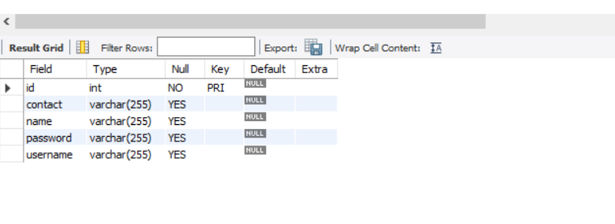

**Question Table Structure**

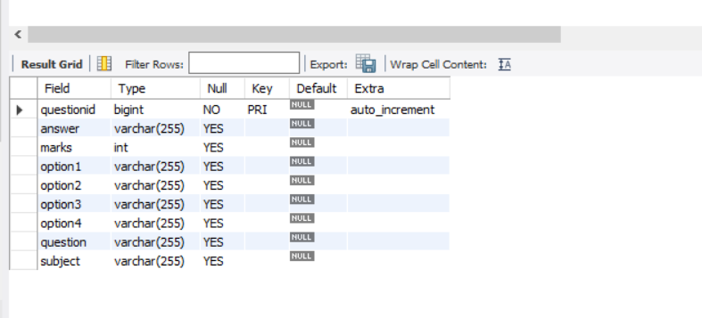

**Rule Table Structure**

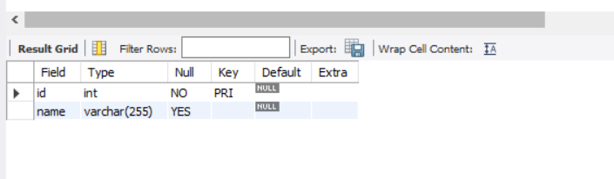

**Admin Table Structure**

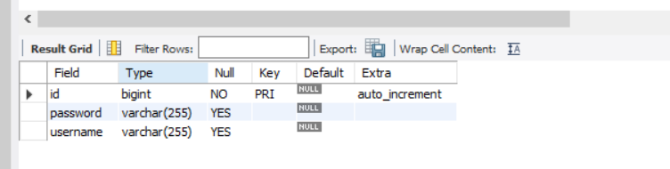

**User Table Structure**

